How would you hog all resources and hang the device within 4 minutes?

Consider if the device runs in a Linux OS, even though we don't have root access to the device/server we can utilize the cores of the CPU to the max efficiency.

1. One option is to run the infinite loop.

If you have 4-core CPU then run the below code,

***for i in 1 2 3 4; do while : ; do : ; done & done***

It starts the four infinite/endless loops and each of them is repeating the null instruction. And so each loop is able to load CPU 100%

1. The other option is to run this command ***sha1sum /dev/zero &***

If you have 4-core CPU run the above commands for 4 times.

Later you will be able to see the loads by using top –c command.

Reference Screenshots:

Option 1: Ran 4 infinite loop:



Checked using top –c command

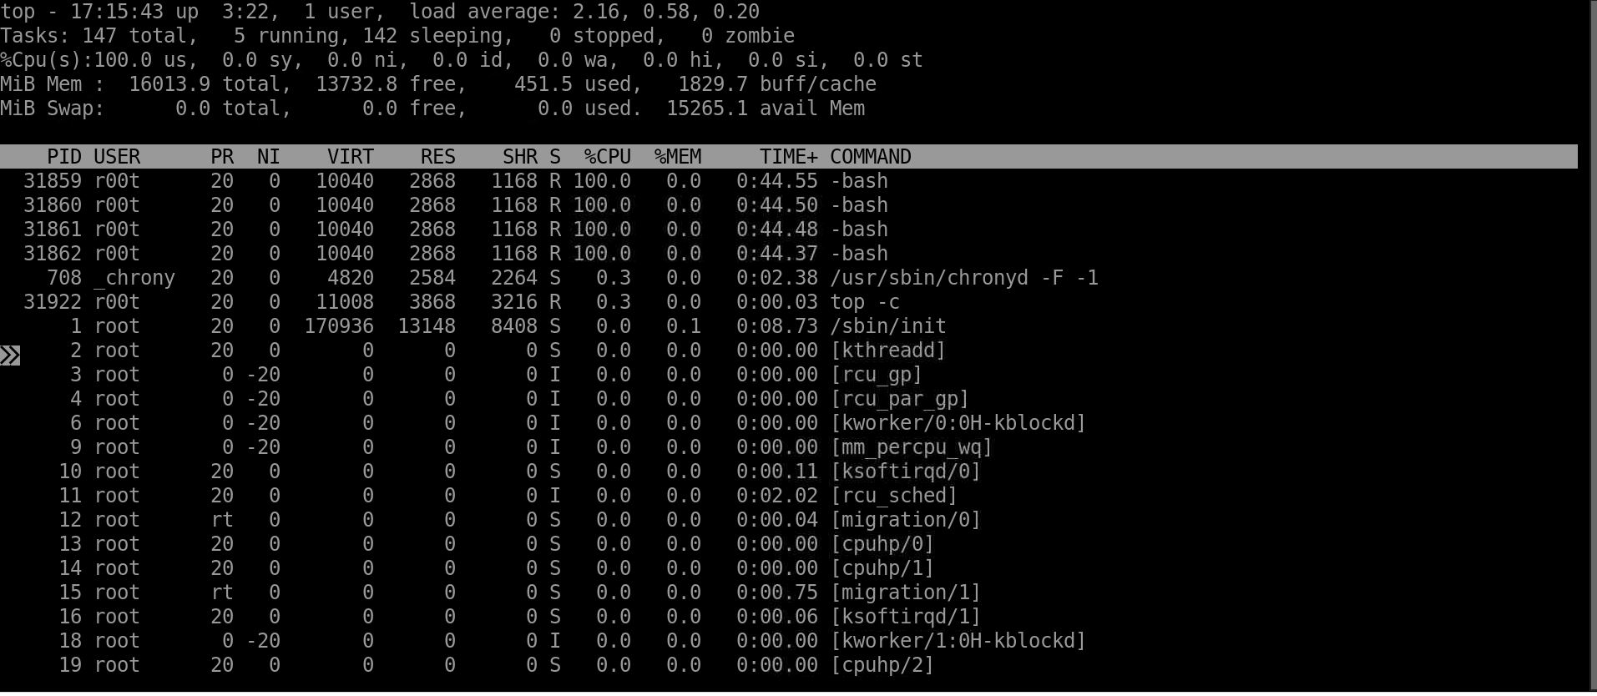

Option 2:

